HISPANICIZE 2013 SPONSOR KIT
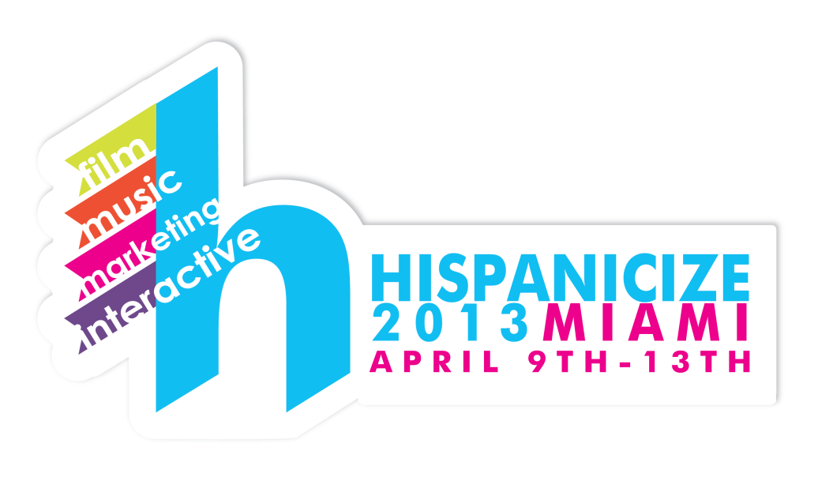
Why Hispanicize?
This is a good place to talk about the conference or event and why it would be a great place for the brand to be represented…
Hispanicize connects brands, media, marketers, celebrities, filmmakers, innovators and bloggers in a unique environment focused on creative ideas and best practices. The conference is a launch pad for creative endeavors, new products, technologies, marketing campaigns, films, books and more targeting Latinos. Now in its fourth year, Hispanicize is the iconic annual event for Latino trendsetters and newsmakers in social media, marketing, entertainment and innovation.
As a rising Latina blogger, I believe that Hispanicize 2013 is an exceptional event that can help me to take my blog to the next level and amplify the message of MyBlog.com and the brands and organizations that I partner with. Hispanicize offers a unique opportunity to connect with influential Latina bloggers, top news and media outlets, and to attend exclusive pro-blogging and business sessions targeted specifically to the digital Latino community.
About MyBlog.com
Write two or three paragraphs about yourself. Tell your potential sponsors a little bit about yourself, why you blog and what your blog is about.

YOUR HEAD SHOT
In a second paragraph, tell them what makes your blog so special. Why is it such a great fit for them? What audience does your blog reach? How influential are you?

PERSONAL OR BLOG BRANDING IMAGE
MyBlog.com Reach & Influence
MyBlog.com readers are an engaged audience coming to MyBlog for parenting tips, recipes, fashion …
Tell the individuals you are pitching a little bit more about your audience. Who they are, what topics you share on the blog, what your readers value about your site, etc.
I have been featured on Mamiverse.com, Huffington Post Latino Voices and…
Tell your sponsor about where you have been featured, interviews, events you’ve hosted and anything else that you can think of to demonstrate your influence and reach online…
The more you can say about your experience, the better…so please don’t be shy.

Stats for MyBlog.com:
Avg. Unique Monthly Visitors: 3,000+
Avg. Monthly Pageviews: 12,000+
Twitter Followers: 1,200+
Facebook Fans: 900+
Instagram Followers: 300+
Pinterest Followers: 350+
Linkedin Connections: 500+
Google + Followers: 200+
Google Page Rank: PR 3
Alexa: 333,000 Global / 60,000 US, 150 backlinks

AS SEEN ON (add a cool graphic to show where you’ve contributed):

SPONORSHIP OPPORTUNITIES

PLATINUM SPONSOR - $1,200 (one opportunity available)
- Exclusive Leaderboard or 300x250 ad above the fold on MyBlog.com during the month of the event, and for an additional month following the event;
- Representation of your brand at private parties during the conference;
- 1 sponsored posts about your brand, during the month of the conference;
- 1 recap post to be published LIVE during the event with a mention of your brand, plus a logo and link;
- MINIMUM 10 LIVE Tweets & 5 FB Shares mentioning your brand during the week of the event;
- Additional Tweets and Shares included as posts or recaps are published;
- Please inquire about other options or accommodations.

PREMIER SPONSOR - $600 (up to two opportunities available)
- One 300x250 ad displayed below the fold on MyBlog.com during the month of the event;
- 1 sponsored post about your brand within 30 days of the event ;
- 1 recap post to be published LIVE during the event with a mention of your brand, plus a link;
- MINIMUM of 5 LIVE Tweets & 2 FB Shares mentioning your brand during the event;
- Additional Tweets and Shares included with published posts;

CONTRIBUTING SPONSOR - $350 (up to three opportunities available)
- One 300x250 ad displayed below the fold on MyBlog.com for one month following the event;
- 1 sponsored post about your brand to be published following the event;
- MINIMUM of 3 LIVE Tweets & 1 LIVE FB Share mentioning your brand during the event;
- Additional Tweets and Shares included with published posts;

